# Start of Exam

This sample exam paper has been prepared to help students be a little more aware as to the style and content of questions that they may face in the final exam. You should note that this is an abbreviated exam paper, being only out of 261*/*2 marks. The final exam paper will typically be:

* **TNE10006** – 90-100 marks
* **TNE60006** – 100-110 marks

One or two example questions from each of the actual 9 main questions on the final exam paper are provided here excluding the VLSM question.

Jason

**Q1** Consider the 802.3 Ethernet Protocol.

* 1. Do collisions occur in a switched network? Why/Why Not?
  2. Describe CSMA/CA Protocol
  3. Describe CSMA/CD Protocol
  4. What is the main difference between CSMA/CD and CSMA/CA
  5. What is the use of FCS field in Ethernet trailer?
  6. What is the maximum length of Ethernet Frame with Header and Trailer?

**Q2** Consider the IP Protocol

1. Answer each of the following questions **TRUE** or **FALSE**:
   1. 57.69.168.31/27 is a valid host IP address (1 mark)

**ii.** 205.64.87.17 is in the 205.64.87.0/26 subnet (1 mark)

1. An IP Packet of size 5,730 bytes is sent over a link with a 600 byte MTU
   1. How many IP fragments are sent?

(1 mark)

* 1. Fragment 3 is lost, will the IP layer request a retransmission?

(1 mark)

1. Write the following IPv6 addresses in abbreviated form:

**i.** 48a4:00b4:0000:0000:0000:0000:cd00:0a7b

(1 mark)

1. Consider the host with the IPv6 Address 2001:16d4:b:4:13a1:18ee:ed2b:8f7b/64
   1. What is the Site Address Space ID with prefix?
2. mark)
   1. What is the ISP address with prefix for the above IPv6?
   2. What is Registry Space address with prefix for the above IPv6?
   3. What is the Subnet with prefix for the above IPv6?
   4. What is the first usable address of the above IPv6, supposed we use the prefix with the largest possible amount of host?
   5. What is the last usable address of the above IPv6, supposed we use the prefix with the largest possible amount of host?
3. Consider the host with the IPv6 2001:0DB8:9BAD:BABE:0DE8:AB78:2301:0010/62
   1. What is the prefix for the above IPv6?
   2. What is the total amount of hosts possible if the prefix is /64?

**Q3** Question 3 is a VLSM question worth 15 marks. You should understand the type of question without a sample.

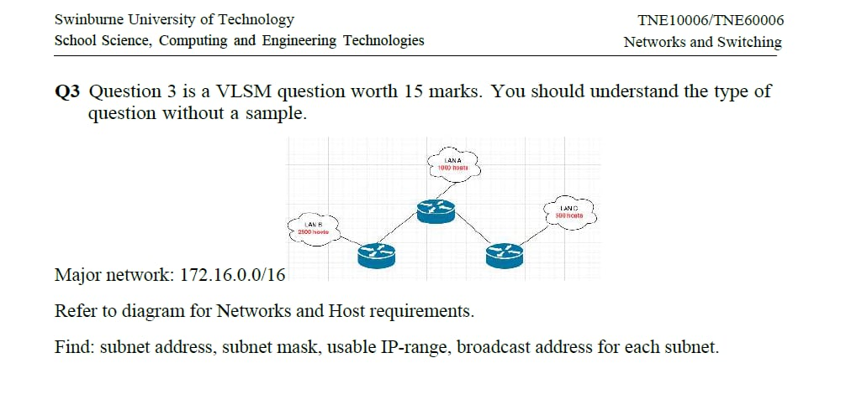

**Q4** This question concerns Transport Layer Protocols

1. Consider the TCP Three-Way Handshake depicted in the figure below, the se- quence number of the first **SYN** packet is 1,543



* 1. How many bytes of data are contained within the first SYN Packet?

(1 mark)

* 1. In the **SYN-ACK** response, what is the Acknowledgement number?

(1 mark)

* 1. What is the sequence number in the **SYN-ACK** response?

(2 marks)

* 1. How many bytes of data may the sender include in the final **ACK** packet?

1. Consider the TCP Three-Way Handshake depicted in the figure below, the se- quence number of the **second** **SYN** packet is 100, and the **first** Syn is **x**



* 1. How many bytes of data are contained within the first SYN Packet?

(1 mark)

* 1. In the **SYN-ACK** response, what is the Acknowledgement number?

(1 mark)

* 1. What is the sequence number in the **SYN-ACK** response?

(2 marks)

* 1. How many bytes of data may the sender include in the final **ACK** packet?

(1 mark)

**Q5** Consider the following network with assiciated IP Address, MAC Address and ARP/MAC table information

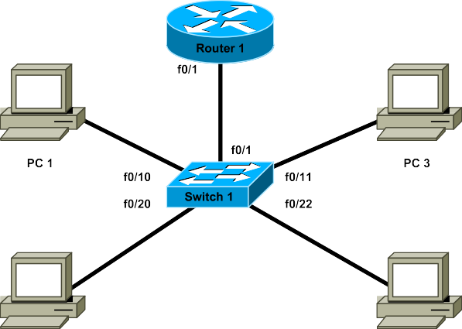**PC 1**

**PC ARP Tables**

|  |  |
| --- | --- |
| **IP** | **MAC** |
| 192.168.10.1 | aa:bb:cc:dd:ee:99 |

**Interface Configuration Details**

**PC 2**

|  |  |
| --- | --- |
| **IP** | **MAC** |
| Empty |  |

**PC 3**

|  |  |
| --- | --- |
| **IP** | **MAC** |
| Empty |  |

**PC 4**

|  |  |
| --- | --- |
| **IP** | **MAC** |
| Empty |  |

**Router 1**

|  |  |
| --- | --- |
| **IP** | **MAC** |
| 192.168.10.6 | aa:bb:cc:dd:ff:01 |

**Switch 1 MAC Table**

|  |  |  |  |  |
| --- | --- | --- | --- | --- |
| **Device** | **Interface** | **VLAN** | **MAC** | **IP** |
| **Router 1** | f0/1.10 | 10 | aa:bb:cc:dd:ee:99 | 192.168.10.1 |
| f0/1.20 | 20 | aa:bb:cc:dd:ee:99 | 192.168.20.1 |
| f0/1.99 | 99 | aa:bb:cc:dd:ee:99 | 192.168.99.1 |
| **Switch 1** | f0/1 | Trunk | – | – |
| f0/10 | 10 | – | – |
| f0/11 | 10 | – | – |
| f0/20 | 20 | – | – |
| f0/22 | 20 | – | – |
| vlan99 | 99 | aa:bb:cc:dd:00:99 | 192.168.99.5 |
| **PC 1** | – | – | aa:bb:cc:dd:ff:01 | 192.168.10.6 |
| **PC 2** | – | – | aa:bb:cc:dd:ff:02 | 192.168.20.7 |
| **PC 3** | – | – | aa:bb:cc:dd:ff:03 | 192.168.10.8 |
| **PC 4** | – | – | aa:bb:cc:dd:ff:04 | 192.168.20.9 |

|  |  |
| --- | --- |
| **MAC** | **Port** |
| aa:bb:cc:dd:ee:99 | f0/1 |
| aa:bb:cc:dd:ff:01 | f0/10 |

1. When a packet from PC1 to PC4 traverses the trunk link from **Switch 1** to

**Router 1**, fill in the following information as seen in the packet headers

|  |  |  |
| --- | --- | --- |
|  | **Source** | **Destination** |
| **MAC** |  |  |
| **IP** |  |  |

1. When a packet from PC2 to PC3 traverses the trunk link from **Switch 1** to

**Router 1**, fill in the following information as seen in the packet headers

|  |  |  |
| --- | --- | --- |
|  | **Source** | **Destination** |
| **MAC** |  |  |
| **IP** |  |  |

1. In the above question, does **PC2** needs to ARP for **PC3**? if yes fill in the following information when the packet traverse the trunk link from **Router 1** to **PC3**

|  |  |  |
| --- | --- | --- |
|  | **Source** | **Destination** |
| **MAC** |  |  |
| **IP** |  |  |

1. After that does **PC3** needs to **ARP** for **PC2**? Fill in the following information when the packet traverse the trunk link from **Router1** to **PC2**

|  |  |  |
| --- | --- | --- |
|  | **Source** | **Destination** |
| **MAC** |  |  |
| **IP** |  |  |

1. In the above picture, there is a disadvantage of the topology, what could it possibly be?
2. Supposed the main Switch does not have VLAN30 on it, what could go wrong?

1. **In the above picture do we need to configure trunk link? If yes then where should we configure it?**
2. **What could go wrong if we don’t configure trunk link between Larry and Curly?**
3. **Does Curly have to be configure with PC VLAN if we need to ping Ethernet PC and VAN PC?**

**Q6** This question relates to the Spanning Tree Protocol

**a)** How is it possible to configure Cisco Switches such that a different switch be- comes the root bridge for each VLAN?

(2 marks)

**a)** Fill in the below picture will all necessary information about ports of each switch.

**Q7** This question refers to aspects of the design of Switched networks

1. At which layer(s) in a Heirarchical network (*Core, Distribution or Access*) are the following switch features most important (*you may tick more than one layer* )

|  |  |  |  |
| --- | --- | --- | --- |
| **Switch Feature** | **Core** | **Distribution** | **Access** |
| Power over Ethernet |  |  |  |

(1*/*2 mark)

1. Describe briefly what the term **Converged Network** means?
2. mark)
3. What is Separate Network means?
4. mark)
5. Describe Access Layer Features

(1 mark)

**Q8** This question is about Ethernet Switching and VLANs

1. Nominate one advantage and one disadvantage to using trunking instead of Access Ports when connecting a Switch to another Switch or Router?

## Advantage

(1 mark)

## Disadvantage

(1 mark)

1. Briefly explain how each of the following benefits are realised through the use of VLANs

## Cost Reduction

(2 marks)

## (4 marks)

**Q9** Consider a wireless network

**a)** What purpose does the SSID serve in a Wireless network?

(1 mark)

**b)** Describe Three Stage Association Process when a PC connect to an AP

(1 mark)

**c)** Describe DoS attack

(1 mark)

# End of Exam

## Student Marks – Staff Use Only

|  |  |  |  |  |  |  |  |  |  |  |
| --- | --- | --- | --- | --- | --- | --- | --- | --- | --- | --- |
| Question: | 1 | 2 | 3 | 4 | 5 | 6 | 7 | 8 | 9 | Total |
| Points: | 3 | 6 | 0 | 5 | 4 | 2 | 11*/*2 | 4 | 1 | 261*/*2 |
| Score: |  |  |  |  |  |  |  |  |  |  |